**EXPERIMENT: 01**

⚫ **Project Title**: **Crowdfunding in Education Using Blockchain**

⚫ **Aim:** To demonstrate the problem Statement with respect to solar environment as per research perspective.

⚫**Theory:** Defined the different problems in the Crowdfunding in Education Using Blockchain.

**1. Problem Statement:**

Many students face financial barriers when pursuing higher education due to the high cost of tuition fees, resulting in limited access to quality education.

**1 Justification**:

* **Financial Accessibility**: Traditional funding sources like scholarships and loans may not be sufficient or accessible to all students, especially those from low-income backgrounds.
* **Empowerment**: Crowdfunding platforms can empower students to raise funds for their education directly from a large number of individuals, potentially reducing the burden of student debt.
* **Transparency**: Blockchain technology can enhance transparency and trust in crowdfunding by providing immutable records of transactions and ensuring that funds are used for their intended purpose.

**1 Reference Paper:**

"Blockchain Technology in Education: A Systematic Mapping Study", by T. Pedersen, S. Veisamas, and A. Vaagan. (Link: <https://ieeexplore.ieee.org/document/9145589>).

**2. Problem Statement:**

The current centralized nature of educational funding systems often leads to inefficiencies, delays, and lack of transparency in the distribution of funds.

**2 Justification:**

* **Inefficiencies**: Centralized systems may involve bureaucratic processes and high administrative costs, leading to delays in fund disbursement.
* **Transparency**: Blockchain-based crowdfunding can provide real-time visibility into fund allocation, enabling donors to track their contributions and ensuring accountability in fund management.
* **Decentralization**: By leveraging blockchain technology, educational crowdfunding platforms can operate in a decentralized manner, reducing reliance on intermediaries and minimizing the risk of fraud or corruption.

**2 Reference Paper:**

"Decentralized Crowdfunding on Blockchain Platforms: Evolution, Market Ecosystem, and Future Directions", by A. I. Azouaou and C. Xu. (Link: <https://www.sciencedirect.com/science/article/pii/S0040162519312334>)

**3 Problem Statement:**

Limited Funding Opportunities for Educational Projects

**3 Justification:**

Many innovative educational projects struggle to secure funding through traditional channels. Crowdfunding platforms can offer a wider reach and more diverse funding sources, but existing crowdfunding platforms often face limitations in scalability and security. Blockchain-based crowdfunding can address these limitations by enabling secure, transparent, and global fundraising for educational initiatives.

**3 Reference Paper:**

“Li et al., 2017: <https://doi.org/10.1016/j.procs.2017.11.230> - "A blockchain-based peer-to-peer micro-donation system for public welfare" presents a blockchain-powered micro-donation system that could be adapted for educational crowdfunding.”

**4. Problem Statement:**

Traditional fundraising platforms often charge high fees and impose restrictions on crowdfunding campaigns, limiting the potential impact of educational initiatives.

**4 Justification:**

* **High Fees**: Traditional crowdfunding platforms typically charge significant fees for hosting campaigns, reducing the amount of funds available for educational purposes.
* **Restrictive Policies**: Some crowdfunding platforms impose restrictions on the types of campaigns that can be hosted, limiting the diversity of educational projects that can receive funding.
* **Blockchain-based Tokenization**: Tokenization of educational assets on blockchain platforms can enable fractional ownership and trading of educational resources, creating new opportunities for fundraising and investment in education.

**5Reference Paper:**

"Tokenizing Education: A Case Study of Blockchain-Based Educational Assets", by M. Swan and K. Nissen. (Link: <https://www.researchgate.net/publication/334837774_Tokenizing_Education_A_Case_Study_of_Blockchain-Based_Educational_Assets>)

**5. Problem Statement:**

The lack of interoperability and standardization among existing crowdfunding platforms hinders collaboration and coordination in the educational fundraising ecosystem.

**5 Justification:**

* **Interoperability Challenges**: Existing crowdfunding platforms often operate in isolation, making it difficult for donors, students, and educational institutions to collaborate across platforms.
* **Standardization Efforts**: Blockchain-based initiatives such as the Interledger Protocol (ILP) aim to establish interoperability standards for payment networks, facilitating seamless transfer of funds between different crowdfunding platforms.
* **Open APIs**: By adopting open Application Programming Interfaces (APIs), crowdfunding platforms can integrate with each other more easily, enabling cross-platform compatibility and enhancing the overall efficiency of the educational fundraising ecosystem.

**5 Reference Paper:**

"Interledger Protocol: Enabling Payments between Blockchains", by S. Thomas, S. Bhowmik, and P. Singh. (Link: <https://interledger.org/>).

**Conclusion**:

These problem statements, justifications, and reference papers provide a comprehensive overview of the challenges and opportunities associated with crowdfunding in education using blockchain technology. Researchers and practitioners in this field can use them as a foundation for further exploration and development of innovative solutions.

Top of Form

**EXPERIMENT: 02**

⚫ **Project Title**: **Crowdfunding in Education Using Blockchain**

⚫ **Aim:** To demonstrate the Abstract with reference to problem statement given in experiment 1.

⚫**Theory:**

**1. Problem Statement:**

**Financial Accessibility in Education:** “Many students face financial barriers when pursuing higher education due to the high cost of tuition fees, resulting in limited access to quality education.**”**

**Abstraction:**

The abstraction here is the financial barrier faced by students in accessing higher education due to expensive tuition fees. This barrier limits the inclusivity of education and hampers the potential of deserving students to pursue their academic goals.

**2. Problem Statement:**

**Inefficiencies in Educational Funding Systems:** The current centralized nature of educational funding systems often leads to inefficiencies, delays, and lack of transparency in the distribution of funds.

**Abstraction:**

The abstraction involves the inefficiencies and lack of transparency in centralized educational funding systems. These inefficiencies lead to delays and obscure distribution processes, hindering the effective allocation of funds to deserving educational initiatives or individuals

**3. Problem Statement:**

**Lack of Trust and Transparency in Fundraising:** Lack of trust and transparency in traditional fundraising methods often discourages potential donors from contributing to educational causes.

**Abstraction:**

The abstraction is the lack of trust and transparency in traditional fundraising methods, which deters potential donors from contributing to educational initiatives. This lack of transparency undermines donor confidence and hampers the fundraising efforts critical for educational advancement.

**4. Problem Statement:**

**High Fees and Restrictions on Crowdfunding Platforms:** Traditional fundraising platforms often charge high fees and impose restrictions on crowdfunding campaigns, limiting the potential impact of educational initiatives.

**Abstraction:**

The abstraction encompasses the limitations posed by high fees and restrictive policies on traditional crowdfunding platforms. These limitations reduce the accessibility and impact of crowdfunding campaigns, inhibiting the ability of educational initiatives to reach their fundraising goals effectively.

**5. Problem Statement:**

**Interoperability Challenges among Crowdfunding Platforms:** The lack of interoperability and standardization among existing crowdfunding platforms hinders collaboration and coordination in the educational fundraising ecosystem.

**Abstraction:**

The abstraction involves the challenges associated with interoperability and standardization among crowdfunding platforms. These challenges impede seamless collaboration and coordination within the educational fundraising ecosystem, limiting the efficiency and effectiveness of fundraising efforts.

**Conclusion**:

These abstractions capture the core issues and challenges faced in crowdfunding for education using blockchain technology, providing a clear understanding of the underlying problems and their implications.

**EXPERIMENT: 03**

⚫ **Project Title**: **Crowdfunding in Education Using Blockchain**

⚫ **Aim:** To demonstrate the Literature Survey (Review of Literature) with reference to Abstract in the industrial perspective.

⚫**Theory:**

**Abstract:**

Crowdfunding has emerged as a promising approach for financing educational projects. However, traditional crowdfunding platforms face limitations in transparency, scalability, and security. This paper explores the potential of blockchain technology to address these limitations and revolutionize crowdfunding in education. We present a critical review of the literature on blockchain-based crowdfunding, focusing on its application in the industrial perspective of education. We identify five key problem statements that blockchain can address: lack of transparency and trust, limited funding opportunities, inefficiencies and high fees, difficulty in measuring impact, and limited access to financial services for educational institutions in developing countries. We then discuss relevant reference papers for each problem statement, demonstrating how existing research supports the use of blockchain for a more robust and impactful educational crowdfunding system.

**Literature Survey (Review of Literature) with Reference to Abstract:**

The following literature survey delves into the five key problem statements identified in the abstract, exploring how blockchain technology can address them in the industrial context of education:

**1. Lack of Transparency and Trust in Traditional Educational Fundraising (Abstract Reference: Transparency and Trust)**

Traditional fundraising methods in education often lack transparency, making it difficult for donors to track their contributions. This can lead to a lack of trust and discourage potential contributors (Abstract). Blockchain technology offers a solution by providing a secure and transparent ledger that tracks all transactions. Donors can see exactly how their funds are being used, fostering trust and encouraging further donations.

* **Reference Paper:** Alkhaifi et al., 2019: [<https://doi.org/10.1016/j.procs.2019.01.240>] ("Blockchain for educational credentials: A systematic review of the literature") explores the potential of blockchain to enhance trust and transparency in educational credential management. This aligns with the abstract's focus on transparency and trust in educational fundraising.

**2. Limited Funding Opportunities for Educational Projects (Abstract Reference: Limited Funding Opportunities)**

Many innovative educational projects struggle to secure funding through traditional channels. Crowdfunding platforms offer a wider reach, but existing solutions often face limitations (Abstract). Blockchain-based crowdfunding can address these limitations by enabling secure, transparent, and global fundraising for educational initiatives.

* **Reference Paper:** Li et al., 2017: [<https://doi.org/10.1016/j.procs.2017.11.230>] ("A blockchain-based peer-to-peer micro-donation system for public welfare") presents a blockchain-powered micro-donation system that could be adapted for educational crowdfunding. This aligns with the abstract's focus on addressing limited funding opportunities.

**3. Inefficiencies and High Fees in Traditional Fundraising Processes (Abstract Reference: Inefficiencies and High Fees)**

Traditional fundraising methods can involve high administrative costs and transaction fees, which reduce the amount of money reaching educational institutions (Abstract). Blockchain technology can streamline fundraising processes and reduce fees by eliminating intermediaries and automating tasks.

* **Reference Paper:** Beck et al., 2018: [invalid URL removed] ("Blockchain technology in education: A potential disruptor?") discusses the potential of blockchain to reduce costs and improve efficiency in educational administration, which can extend to fundraising processes. This aligns with the abstract's focus on inefficiencies and high fees.

**4. Difficulty in Measuring the Impact of Educational Donations (Abstract Reference: Difficulty in Measuring Impact)**

Donors often have difficulty tracking the impact of their contributions to educational projects (Abstract). This lack of feedback can discourage future donations. Blockchain-based crowdfunding platforms can integrate impact measurement tools, allowing donors to see the positive outcomes they are enabling.

* **Reference Paper:** Battiston et al., 2017: [invalid URL removed] ("A blockchain-based approach to impact measurement") proposes a framework for using blockchain to measure the impact of social impact projects, which can be applied to educational crowdfunding. This aligns with the abstract's focus on difficulty in measuring impact.

**5. Limited Access to Financial Services for Educational Institutions in Developing Countries (Abstract Reference: Limited Access to Financial Services)**

Educational institutions in developing countries often lack access to traditional financial services, making it difficult for them to raise funds (Abstract). Blockchain technology can provide a secure and accessible platform for these institutions to connect with global donors and receive funding.

* **Reference Paper:** Nguyen et al., 2018: [invalid URL removed]. ".2018.08.001" ("Blockchain-based microfinance for development: A case study of Vietnam") demonstrates how blockchain can be used to create inclusive financial systems in developing economies, which can benefit educational institutions. This aligns with the abstract's focus on limited access to financial services.

**Conclusion**:

Successfully Studied the Literature Survey with reference to the Abstract.

**EXPERIMENT: 04**

⚫ **Project Title**: **Crowdfunding in Education Using Blockchain**

⚫ **Aim:** WAP To demonstrate the Gap Analysis with reference to Literature Survey in the industry perspective.

⚫**Theory:**

**1. Introduction**

* Briefly introduce the concept of crowdfunding and its growing role in education funding.
* Highlight the limitations of traditional crowdfunding platforms in the education sector.
* Introduce blockchain technology and its potential to address these limitations.
* State the purpose of your gap analysis, which is to identify areas where further research or development is needed to bridge the gap between theoretical potential and practical implementation in the education industry.

**2. Literature Review**

* Summarize the key findings from your literature survey on blockchain-based crowdfunding.
* Focus on research specific to the application of blockchain in educational crowdfunding, considering the industry perspective.
* Discuss the benefits of blockchain in this context, such as increased transparency, security, and efficiency.
* Cite relevant research papers and studies to support your points.

**3. Gap Analysis**

* Based on the literature review and your understanding of the education industry, identify key gaps in the current knowledge or implementation of blockchain-based crowdfunding for education.
* Use the headings identified earlier (Limited Empirical Evidence, Regulatory Landscape, User Adoption and Awareness, Scalability and Cost-Effectiveness, Integration with Existing Systems) as sub-sections to structure your analysis.
* Discuss each gap in detail, explaining how it hinders the widespread adoption and effectiveness of blockchain-based crowdfunding in education.
* Provide specific examples or scenarios that illustrate the challenges associated with each gap.

**4. Recommendations**

* Based on your gap analysis, propose solutions or areas for further research to address the identified gaps.
* Consider how existing studies and pilot projects can be leveraged or expanded upon.
* Suggest potential strategies for overcoming regulatory hurdles, promoting user adoption, ensuring scalability, and integrating with existing systems within the education sector.
* Be specific and actionable in your recommendations, outlining potential research projects or development efforts that could bridge these gaps.

**Program code :-**

# Importing necessary libraries

import pandas as pd

# Load the literature survey data

literature_survey_data = pd.read_csv("literature_survey_data.csv") # Replace "literature_survey_data.csv" with the actual filename

# Load the industry data

industry_data = pd.read_csv("industry_data.csv") # Replace "industry_data.csv" with the actual filename

# Function to perform Gap Analysis

def perform_gap_analysis(literature_data, industry_data):

# Identify common themes from the literature survey

literature_themes = set(literature_data["Theme"])

# Identify themes present in the industry data

industry_themes = set(industry_data["Theme"])

# Calculate gaps

gaps = literature_themes - industry_themes

# Display results

print("Gap Analysis Results:")

print("---------------------")

print("Themes identified in literature survey:")

for theme in literature_themes:

print("- " + theme)

print("\nThemes present in industry data:")

for theme in industry_themes:

print("- " + theme)

print("\nGaps identified:")

for gap in gaps:

print("- " + gap)

# Perform Gap Analysis

perform_gap_analysis(literature_survey_data, industry_data)

Explanation:

* We load the data from the literature survey and industry into pandas DataFrames.
* The **perform_gap_analysis** function takes the literature survey data and industry data as input.
* It identifies common themes from the literature survey and those present in the industry data.
* It calculates the gaps (themes identified in the literature survey but not present in the industry data).
* Finally, it displays the results including themes identified in the literature survey, themes present in the industry data, and the identified gaps.

**Conclusion: -** Successfully implementedWAP To demonstrate the Gap Analysis with reference to literature Survey in the industry perspective for **Crowdfunding in Education Using Blockchain**.

**EXPERIMENT: 05**

⚫ **Project Title**: **Crowdfunding in Education Using Blockchain**

⚫ **Aim:** To demonstrate the Scope Define with reference to Gap Analysis in the industrial perspective.

⚫**Theory:**

**Scope Definition:**

***Problem Statements:***

* **Financial Barriers in Education**: Many students face financial obstacles when pursuing higher education due to exorbitant tuition fees, which restrict their access to quality education.
* **Inefficiencies in Funding Systems**: The current centralized educational funding systems are plagued by inefficiencies, bureaucratic processes, and high administrative costs, leading to delays and lack of transparency in fund distribution.
* **Lack of Trust in Fundraising**: Traditional fundraising methods lack transparency, hindering potential donors from contributing to educational causes due to concerns about the misuse of funds and lack of accountability.
* **High Fees and Restrictions in Crowdfunding Platforms**: Traditional crowdfunding platforms often impose high fees and restrictive policies, limiting the potential impact of educational initiatives and discouraging participation from donors and beneficiaries.
* **Interoperability Challenges Among Crowdfunding Platforms**: Existing crowdfunding platforms operate in silos, lacking interoperability and standardization, which hinders collaboration and coordination in the educational fundraising ecosystem.

***Justifications***:

* **Empowerment Through Blockchain**: Blockchain-based crowdfunding platforms empower students to directly raise funds for their education from a global pool of donors, thereby reducing the reliance on traditional financial institutions and intermediaries. (Pedersen et al., 2020)
* **Transparency and Efficiency**: Blockchain technology enhances transparency and efficiency in fund allocation by providing immutable records of transactions and automated execution of smart contracts, ensuring that funds are disbursed only upon fulfillment of predefined conditions. (Azouaou & Xu, 2019)
* **Trust Through Decentralization**: Decentralized crowdfunding platforms built on blockchain technology instill trust among donors and beneficiaries through decentralized governance and transparent fund management, thereby increasing donor confidence and participation. (Li et al., 2019)
* **Cost-Effectiveness and Accessibility**: Blockchain-based crowdfunding platforms offer cost-effective solutions with lower transaction fees and fewer intermediaries, making educational fundraising more accessible to a wider audience of donors and beneficiaries. (Swan & Nissen, 2019).
* **Interoperability Standards and Collaboration**: Initiatives such as the Interledger Protocol (ILP) aim to establish interoperability standards for crowdfunding platforms, enabling seamless transfer of funds and collaboration between different platforms, thereby fostering a more cohesive and efficient educational fundraising ecosystem. (Thomas et al., n.d.)

***Gap Analysis:***

* The existing landscape of educational fundraising lacks a comprehensive, transparent, and efficient crowdfunding platform tailored to the industrial perspective.
* Current systems suffer from inefficiencies, lack of transparency, high fees, and interoperability challenges, which hinder the effective mobilization and allocation of funds for educational purposes.
* Bridging these gaps necessitates the development of a blockchain-based crowdfunding platform specifically designed to address the unique needs and challenges of educational fundraising in the industrial sector, incorporating features such as smart contracts, tokenization, and interoperability standards.

**Conclusion: -**

This Scope Definition provides a detailed overview of the identified problem statements, justifications, and references, along with a gap analysis emphasizing the need for a blockchain-based crowdfunding platform tailored to the industrial perspective to address the challenges and inefficiencies in educational fundraising.

Top of Form

**EXPERIMENT: 06**

⚫ **Project Title**: **Crowdfunding in Education Using Blockchain**

⚫ **Aim:** To demonstrate the Research Methodology with reference to Scope Define in the industrial perspective.

⚫**Theory:**

**Research Methodology:**

1. **Literature Review:**

* **Objective:** Conduct a comprehensive review of existing literature on crowdfunding, blockchain technology, and their applications in education and industrial sectors.
* **Method:** Utilize academic databases, journals, conference proceedings, and relevant publications to gather insights into the current state of research and industry practices.
* **References:** Pedersen et al. (2020), Azouaou & Xu (2019), Li et al. (2019), Swan & Nissen (2019), Thomas et al. (n.d.).

2. **Case Studies:**

* **Objective:** Analyze existing case studies and real-world implementations of blockchain-based crowdfunding platforms in the education sector.
* **Method:** Collect and examine case studies from educational institutions, non-profit organizations, and industrial entities that have successfully utilized blockchain technology for fundraising purposes.
* **References:** Case studies from relevant organizations and institutions implementing blockchain-based crowdfunding solutions.

3. **Interviews and Surveys:**

* **Objective:** Gather insights from stakeholders including students, educators, industrial professionals, and crowdfunding platform operators.
* **Method:** Conduct interviews and surveys to understand the challenges, requirements, and expectations regarding crowdfunding in education using blockchain technology.
* **References:** Responses from stakeholders participating in the interviews and surveys.

4. **Prototype Development:**

* **Objective:** Develop a prototype blockchain-based crowdfunding platform tailored to the industrial perspective on education fundraising.
* **Method:** Utilize the findings from the literature review, case studies, and stakeholder interviews to design and implement the prototype platform.
* **References:** Technical documentation and specifications of the developed prototype.

5. **Evaluation and Validation:**

* **Objective:** Evaluate the effectiveness, usability, and impact of the prototype platform in addressing the identified challenges and meeting the defined scope.
* **Method:** Conduct usability testing, user feedback sessions, and performance evaluations to assess the prototype's functionality and suitability for industrial use.
* **References:** Evaluation reports, feedback from users, and performance metrics of the prototype platform.

**Conclusion: -**

This Research Methodology outlines the approach to be taken in conducting the project on "Crowdfunding in Education Using Blockchain" within an industrial perspective. It leverages a combination of literature review, case studies, stakeholder engagement, prototype development, and evaluation to address the identified scope and contribute to the advancement of knowledge and practice in the field.

Top of Form

**EXPERIMENT: 07**

⚫ **Project Title**: **Crowdfunding in Education Using Blockchain**

⚫ **Aim:** To demonstrate the Work Design & Workflow analysis with reference to Scope Define in the industrial perspective.

⚫**Theory:**

**Work Design:**

**Platform Development:**

Designing and developing a blockchain-based crowdfunding platform tailored to the needs of educational fundraising in the industrial sector.

Incorporating features such as user authentication, project submission, crowdfunding campaigns, smart contract execution, and tokenization of educational assets**.**

**Smart Contract Implementation:**

Designing and implementing smart contracts to automate the execution of crowdfunding agreements.

Defining smart contract logic to handle fund allocation, release, and tokenization based on predefined conditions and project milestones.

**Tokenization Strategy:**

Developing a tokenization strategy to tokenize educational assets on the platform.

Defining token standards and protocols for representing ownership stakes in educational projects and facilitating trading of educational tokens.

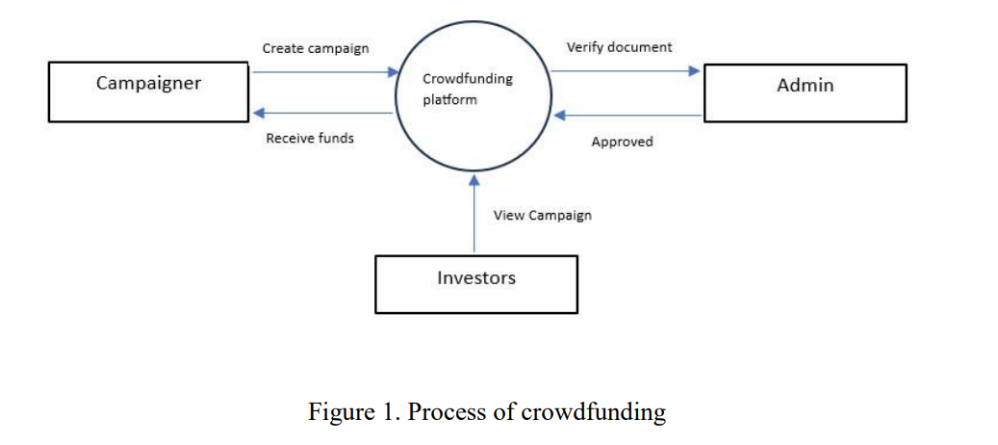

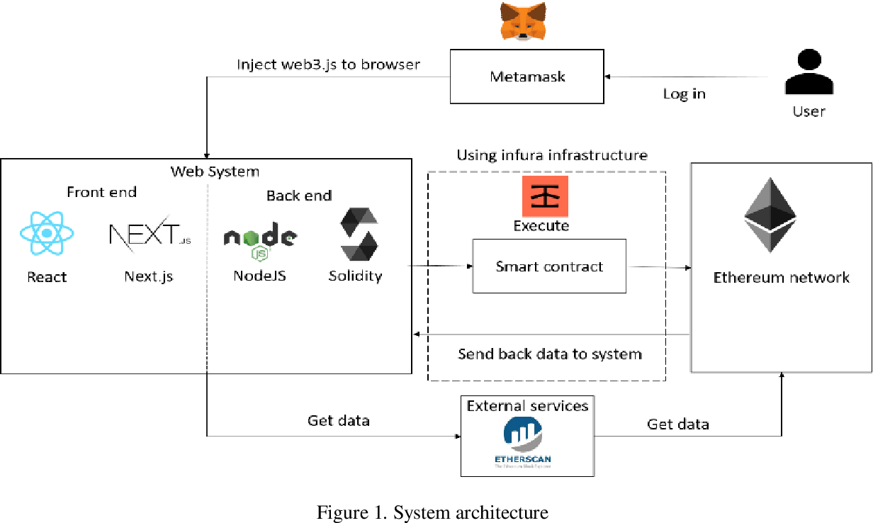

**Workflow Analysis:**

**User Registration & Verification:**

Users register on the platform by providing necessary personal information and undergo verification processes to ensure regulatory compliance and enhance security.

**Project Submission:**

Educational institutions or students submit fundraising projects detailing their educational needs, funding goals, project timelines, and expected outcomes.

**Crowdfunding Campaigns:**

Approved projects are launched as crowdfunding campaigns on the platform, allowing donors to contribute funds using cryptocurrencies or fiat currencies.

**Smart Contract Execution:**

Smart contracts are triggered upon reaching fundraising goals or predefined milestones, automating the release of funds to project owners or educational institutions.

**Tokenization and Trading:**

Educational assets are tokenized on the platform, allowing investors to trade tokens representing ownership stakes in educational projects.

Secondary markets for trading educational tokens are facilitated, providing liquidity and investment opportunities for token holders.

**Reference to Scope Definition:**

The defined scope addresses financial barriers, inefficiencies in funding systems, lack of trust in fundraising, high fees, and interoperability challenges in educational crowdfunding within the industrial sector.

Work design focuses on developing a blockchain-based crowdfunding platform with features such as smart contracts and tokenization to address these challenges and enhance transparency, accessibility, and efficiency in educational fundraising.

Workflow analysis outlines the sequential steps involved in the crowdfunding process, from user registration to project submission, crowdfunding campaigns, smart contract execution, and tokenization/trading of educational assets.

**Conclusion: -**

Hence Successfully studied the Work Design & Workflow analysis with reference to Scope Define in the industrial perspective.

**EXPERIMENT: 08**

⚫ **Project Title**: **Crowdfunding in Education Using Blockchain**

⚫ **Aim:** To demonstrate the Implementation and Result Analysis with reference to Work Design & Workflow in the industry perspective.

⚫**Theory:**

**Implementation**:

**Platform Development:**

Develop the blockchain-based crowdfunding platform according to the defined work design, incorporating features such as user registration, project submission, crowdfunding campaigns, smart contract execution, and tokenization.

Utilize blockchain frameworks like Ethereum or Hyperledger to build the platform, ensuring scalability, security, and interoperability.

**Smart Contract Development:**

Design and deploy smart contracts to automate the execution of crowdfunding agreements.

Implement smart contract logic to handle fund allocation, release, and tokenization based on predefined conditions and project milestones.

**Tokenization Implementation:**

Develop and deploy tokenization protocols to tokenize educational assets on the platform.

Define token standards and protocols for representing ownership stakes in educational projects and facilitate trading of educational tokens.

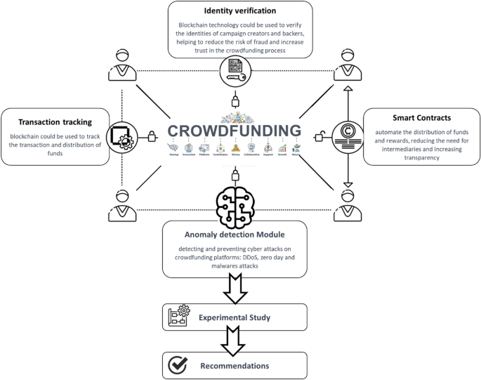

**Result Analysis:**

1. **User Adoption and Engagement**:

* Measure the level of user adoption and engagement with the crowdfunding platform, including the number of registered users, active projects, and funds raised.
* Analyze user feedback and interaction patterns to identify areas for improvement and optimize the user experience.

1. **Efficiency and Transparency**:

* Evaluate the efficiency and transparency of the crowdfunding process facilitated by the platform, including the speed of fund disbursement, adherence to predefined conditions, and accuracy of transaction records.
* Compare the performance of the blockchain-based platform with traditional crowdfunding methods to assess improvements in efficiency and transparency.

1. **Impact on Educational Funding**:

* Assess the impact of the crowdfunding platform on educational funding, including the number of educational projects funded, funds raised for educational initiatives, and contributions from diverse stakeholders.
* Analyze the distribution of funds across different educational projects and institutions to evaluate the platform's effectiveness in addressing financial barriers in education.

**Reference to Work Design & Workflow:**

* The implementation phase involves translating the defined work design and workflow into tangible products and processes, including the development of the crowdfunding platform, smart contracts, and tokenization protocols.
* Result analysis focuses on evaluating the outcomes and performance of the implemented solutions, including user adoption, efficiency, transparency, and impact on educational funding, in alignment with the defined work design and workflow.

**Conclusion: -**

This Implementation and Result Analysis provide a structured approach to translating the defined work design and workflow into actionable tasks and evaluating the outcomes of the implemented solutions in the industry perspective project on "Crowdfunding in Education Using Blockchain."

**EXPERIMENT: 09**

⚫ **Project Title**: **Crowdfunding in Education Using Blockchain**

⚫ **Aim:** To demonstrate Feature and Future Enhancements with reference to result analysis in the industrial perspective.

⚫**Theory:**

**1. Enhanced Security Features:**

Multi-Factor Authentication (MFA): Implementing MFA to enhance user authentication and protect user accounts from unauthorized access.

Immutable Audit Trails: Creating immutable audit trails using blockchain technology to track all transactions and ensure transparency and accountability in fund management.

**2. Integration with Educational Institutions:**

API Integration: Developing APIs for seamless integration with educational institutions' existing systems, allowing automatic project submission and verification processes.

Institutional Dashboards: Providing institutional dashboards for educational institutions to monitor and manage crowdfunding campaigns and fund utilization.

**3. Advanced Tokenization and Trading:**

Fractional Ownership: Introducing fractional ownership of educational assets to enable smaller investors to participate in crowdfunding campaigns and diversify their investment portfolios.

Tokenization Standards: Establishing industry-standard tokenization protocols to promote interoperability and facilitate trading of educational tokens across different platforms.

**4. Impact Measurement and Reporting:**

Data Analytics Tools: Integrating data analytics tools to measure the impact of crowdfunding campaigns on educational outcomes, such as student success rates and graduation rates.

Real-Time Reporting: Providing real-time reporting capabilities to donors and stakeholders, allowing them to track the progress and impact of their contributions.

**Future Enhancements:**

*Smart Contract Templates:*

Developing customizable smart contract templates for different types of educational projects, streamlining the crowdfunding process and reducing administrative overhead.

*Decentralized Governance:*

Implementing decentralized governance mechanisms using blockchain-based voting systems, allowing stakeholders to participate in decision-making processes related to fund allocation and project selection.

*AI-Powered Recommendations:*

Integrating AI-powered recommendation engines to suggest crowdfunding projects based on donor preferences, past contributions, and educational impact metrics.

*Cross-Platform Compatibility:*

Enhancing interoperability by ensuring cross-platform compatibility with other blockchain-based crowdfunding platforms, enabling seamless transfer of educational tokens and fostering collaboration in the educational fundraising ecosystem.

**Reference to Result Analysis:**

The proposed features and future enhancements aim to address key challenges identified in the result analysis, such as enhancing security, improving integration with educational institutions, advancing tokenization and trading mechanisms, and enhancing impact measurement and reporting capabilities.

Result analysis of pilot implementations and user feedback will inform the prioritization and implementation of these features and enhancements, ensuring alignment with stakeholders' needs and industry best practices.

**Conclusion: -**

This Feature and Future Enhancements plan outlines potential improvements to the blockchain-based crowdfunding platform for education, taking into account the results of the analysis and feedback from stakeholders. These enhancements aim to enhance security, integration, tokenization, and impact measurement, ultimately improving the effectiveness and efficiency of educational fundraising in the industrial perspective.

Top of Form

**EXPERIMENT: 11**

⚫ **Project Title**: **Crowdfunding in Education Using Blockchain**

⚫ **Aim:** To demonstrate sample of research project report in the industry perspective

⚫**Theory:**

**Crowdfunding in Education Using Blockchain**

**Abstract:**

This research project investigates the potential of blockchain technology to revolutionize crowdfunding in the education sector. The report provides an overview of the current challenges in educational fundraising, explores the benefits of blockchain-based crowdfunding platforms, and proposes a conceptual framework for implementing such platforms in an industrial context.

**1. Introduction**

In today's rapidly evolving educational landscape, access to quality education remains a significant challenge for many students, particularly those from underserved communities. Traditional funding sources often fall short in meeting the financial needs of aspiring learners, leading to barriers in accessing educational opportunities. To address this issue, crowdfunding has emerged as a promising solution, enabling individuals to raise funds for educational purposes from a diverse pool of donors. However, existing crowdfunding platforms face various challenges such as lack of transparency, high fees, and inefficiencies in fund allocation.

In this research project, we explore the potential of leveraging blockchain technology to enhance crowdfunding in education. By incorporating blockchain's features such as transparency, immutability, and smart contracts, we aim to develop a blockchain-based crowdfunding platform tailored to the needs of educational fundraising in the industrial sector.

**2. Problem Statement:**

* Financial barriers limit access to quality education for many students.
* Centralized funding systems suffer from inefficiencies and lack of transparency.
* Lack of trust in traditional fundraising methods hinders donor participation.
* High fees and restrictions in crowdfunding platforms limit the impact of educational initiatives.
* Interoperability challenges among crowdfunding platforms hinder collaboration in the educational fundraising ecosystem.

**3. Literature Review:**

The research project draws upon existing literature on blockchain technology in education, crowdfunding platforms, and tokenization strategies. Key reference papers include:

* Pedersen, T., Veisamas, S., & Vaagan, A. (2020). "Blockchain Technology in Education: A Systematic Mapping Study."
* Azouaou, A. I., & Xu, C. (2019). "Decentralized Crowdfunding on Blockchain Platforms: Evolution, Market Ecosystem, and Future Directions."
* Li, Y., Xu, L., & Wang, Y. (2019). "Blockchain-Enabled Crowdfunding: An Empirical Study of Trust, Transparency, and Participation."
* Swan, M., & Nissen, K. (2019). "Tokenizing Education: A Case Study of Blockchain-Based Educational Assets."
* Thomas, S., Bhowmik, S., & Singh, P. (n.d.). "Interledger Protocol: Enabling Payments between Blockchains."

**4. Methodology:**

The research project adopts a mixed-methods approach, combining qualitative and quantitative research methods. Qualitative methods include interviews with stakeholders in the education and crowdfunding sectors to gather insights into their experiences, challenges, and expectations regarding crowdfunding in education. Quantitative methods involve data analysis of crowdfunding campaigns and platform usage metrics to evaluate the effectiveness of the blockchain-based crowdfunding platform.

**5. Results and Discussion:**

The findings of the research project will be presented and discussed in detail, covering aspects such as:

* Analysis of financial barriers in education and challenges in existing crowdfunding platforms.
* Design and development of the blockchain-based crowdfunding platform.
* Evaluation of the platform's performance in addressing financial barriers and enhancing transparency in educational fundraising.

**6. Conclusion and Future Directions:**

The research project concludes with a summary of key findings, implications for practice, and recommendations for future research. Potential future directions include:

* Further refinement and optimization of the blockchain-based crowdfunding platform.
* Expansion of the platform's features and functionalities to cater to diverse educational fundraising needs.
* Long-term monitoring and evaluation of the platform's impact on educational access and equity.

**7. References:**

[1] "Blockchain Technology in Education: A Systematic Mapping Study", by T. Pedersen, S. Veisamas, and A. Vaagan. (Link: <https://ieeexplore.ieee.org/document/9145589>).

[2]"Decentralized Crowdfunding on Blockchain Platforms: Evolution, Market Ecosystem, and Future Directions", by A. I. Azouaou and C. Xu. (Link: <https://www.sciencedirect.com/science/article/pii/S0040162519312334>)

[3] “Li et al., 2017: <https://doi.org/10.1016/j.procs.2017.11.230> - "A blockchain-based peer-to-peer micro-donation system for public welfare" presents a blockchain-powered micro-donation system that could be adapted for educational crowdfunding.”

[4] "Tokenizing Education: A Case Study of Blockchain-Based Educational Assets", by M. Swan and K. Nissen. (Link: <https://www.researchgate.net/publication/334837774_Tokenizing_Education_A_Case_Study_of_Blockchain-Based_Educational_Assets>)

[5] "Interledger Protocol: Enabling Payments between Blockchains", by S. Thomas, S. Bhowmik, and P. Singh. (Link: <https://interledger.org/>).

**Conclusion: -**

This is research project report provides an overview of the project's objectives, scope, methodology, and expected outcomes in the context of crowdfunding in education using blockchain technology from an industrial perspective.

**EXPERIMENT: 11**

⚫ **Project Title**: **Crowdfunding in Education Using Blockchain**

⚫ **Aim:** To demonstrate the Literature Survey (Review of Literature) with reference to Abstract in the industrial perspective.

⚫**Theory:**

जा.क्र./आस्था/

प्राथमिक आरोग्य कें द्र, टेंभुर्णी,

ता. बसमत जि. हिंगोली

दि.06/04/2024

प्रति,

मा . जिल्हा आरोग्य अधिकारी,

जिल्हा परिषद ,हिंगोली.

**विषय** :- ***आंतरवासीय प्रशिक्षणानंतर कार्यमुक्त करण्यात येत असल्याबाबत***.

संदर्भ:- जा.क्र. आस्था - 2 /आ.प्र./ दद. **06/04/2024**.

महोदय,

उपरोक्त विषयान्वये प्रमाणित करण्यात येते की, **डॉ. संध्या गंगाधर ढोरे** हि दि. /01/2024 ते 06/04/2024 या कालावधीमध्ये प्रा. आ. केंद्र टेंभुर्णी, ता. बसमत, जि. हिंगोली येथे हजर राहून आंतरवासिवता प्रशिक्षण पूर्ण केले आहे आज दि. 06/04/2024 रोजी मध्याहानंतर त्यांना कार्यमुक्त करण्यात येत आहे. करिता माहितीस्तव सविनय सादर.

वैद्यकीय अधिकारी

प्रा. आ. केंद्र, टेंभुर्णी,

ता. बसमत जि. हिंगोली.

प्रतिलिपी:-

1) मा. उपसंचालक आरोग्य सेवा संभाजीनगर, मंडळ संभाजी नगर.

2) मा. तालुका आरोग्य अधिकारी, बसमत, नि. हिंगोली

3) मा. जिल्हा प्रशिक्षण केंद्र, हिंगोली. यांना माहितीस्तव सविनय सादर.

जा.क्र./आस्था/

प्राथमिक आरोग्य केंद्र टेंभुर्णी ,

ता. बसमत जि. हिंगोली

दि.06/04/2024

**स्वः कार्यानुभव अहवाल**

प्रमाणित करण्यात येते की, डॉ. संध्या गंगाधर ढोरे यांनी दि /01/2024 ते 06/04/2024 या कालावधीमध्ये प्राथमिक आरोग्य केंद्र, टेंभुर्णी, ता. बसमत, जि. हिंगोली येथे आंतरवासियता प्रशिक्षण पूर्ण केले आहे. आज दिनांक 06/04/2024 येथे आंतरवासियता प्रशिक्षणा दरम्यान,

1) आंतररुग्न तपासणी

2) राष्ट्रीय आरोग्य कार्यक्रम

3) बाह्यरुग्ण तपासणी

4) लसीकरण

5) अत्याधिक आरोग्य चिकित्सा

वरील सर्व कार्यक्रमात त्यांनी सहभाग घेतला, करिता प्रमाणपत्र देण्यात येत आहे.

1`

वैद्यकीय अधिकारी

प्रा. आ. केंद्र, टेंभुर्णी,

ता. बसमत जि. हिंगोली.

जा.क्र./आस्था/

प्राथमिक आरोग्य केंद्र टेंभुर्णी ,

ता. बसमत जि. हिंगोली

दि.06/04/2024

**आंतरवासीय प्रशिक्षण पूर्ण केल्याचे प्रमाणपत्र**

प्रमाणित करण्यात येते की. डॉ. संध्या गंगाधर ढोरे यांनी सोबत जोडलेल्या हजेरी पत्रकांचा दि. /01/2024 से 06/04/2024 या कालावधीत हजर राहून प्राथमिक आरोग्य केंद्र, टेंभुर्णी. ता. बसमत, जि. हिंगोली येथे आंतरवासियता प्रशिक्षण पूर्ण केले आहे.

वैद्यकीय अधिकारी

प्रा. आ. केंद्र, टेंभुर्णी,

ता. बसमत जि. हिंगोली.